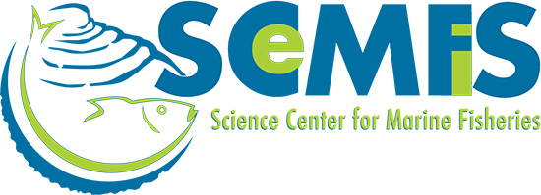
Press Release: Science Center for Marine Fisheries (SCeMFiS)
January 16, 2015
Science Center for Marine Fisheries Collaborates With Independent Advisory Team (IAT) for Marine Mammal Assessments

The Marine Mammal Protection Act (MMPA), which became law in 1972, aimed to stop declines in marine mammal populations, enable depleted populations to recover, prevent future declines, and ensure that whales and dolphins would continue to function effectively in healthy U.S. coastal and ocean environments.

Regulations under the MMPA have imposed changes on the commercial fishing industry, some of which are regarded by fishermen as overly restrictive and burdensome. The law allows for the continued exploitation of fish stocks as long as it was consistent with the Act’s primary objectives. A major challenge facing everyone affected by and involved in MMPA implementation – government regulators, science advisers, and fishermen alike – is how to overcome, or manage, scientific uncertainty.

The Independent Advisory Team (IAT) is a think-tank dedicated to identifying, developing, and promoting research to help reduce uncertainty associated with marine mammal stock assessments. The group reviews the scientific basis for assessment and conservation of marine mammal stocks, particularly in relation to fisheries management, ultimately identifying research priorities, and developing proposals meant to address relevant issues.

The first year’s activities for the IAT centered around increasing understanding of the issues, seeking advice on opportunities for collaboration with scientists in academia, government laboratories, and the private sector, and producing scientific recommendations for the Science Center for Marine Fisheries (SCeMFiS). The IAT is made up of: Paula Moreno (GCRL, University of Southern Mississippi), André Punt (University of Washington), Randall Reeves (Okapi Wildlife Associates), and John Brandon (Greeneridge Sciences).

SCeMFiS is a cooperative venture managed by the Gulf Coast Research Laboratory (GCRL) of the University of Southern Mississippi in Ocean Springs, Mississippi and the Virginia Institute of Marine Science (VIMS), and funded jointly by a 5-year grant from the National Science Foundation (NSF) and industry partner subscriptions. The Center is unique in that industry members take a leadership role in both planning and funding the research needed to promote sustainable fisheries throughout the Mid-Atlantic and Gulf coast regions.

